**National University of Computer & Emerging Sciences**

**Department of Computer Science**

**CL220 Operating Systems Lab**

**Instructions:**

1. Make a word document with the convention “SECTION_ROLLNO _LAB-NO”.
2. You have to submit a Word File (Code implementation + Numerical Solution)

# Note: Implement the following Scheduling algorithms (Round Robin, Preemptive Priority, And Non-Preemptive Priority) in C/C++ and also solve numerically.

# TASK 1

**Consider the following set of processes, with the length of the CPU burst time given in milliseconds:**

|  |  |  |
| --- | --- | --- |
| Process | Burst Time | Priority |
| P1 | 3 | 2 |
| P2 | 1 | 1 (low) |
| P3 | 7 | 4 (high) |
| P4 | 4 | 2 |
| P5 | 5 | 3 |

**The processes are assumed to have arrived in the order P1, P2, P3, P4, P5 all at time 0.**

1. Draw four Gantt charts that illustrate the execution of these processes using the following scheduling algorithms**: Preemptive Priority and Non-Preemptive Priority. [a larger priority number implies a higher priority]**
2. What is the **turnaround time** of each process for each of the scheduling algorithms in part a?
3. What is the **waiting time** of each process for each of these scheduling algorithms?
4. Which of the algorithms results in the **minimum average waiting time** (over all processes)?

# TASK 2

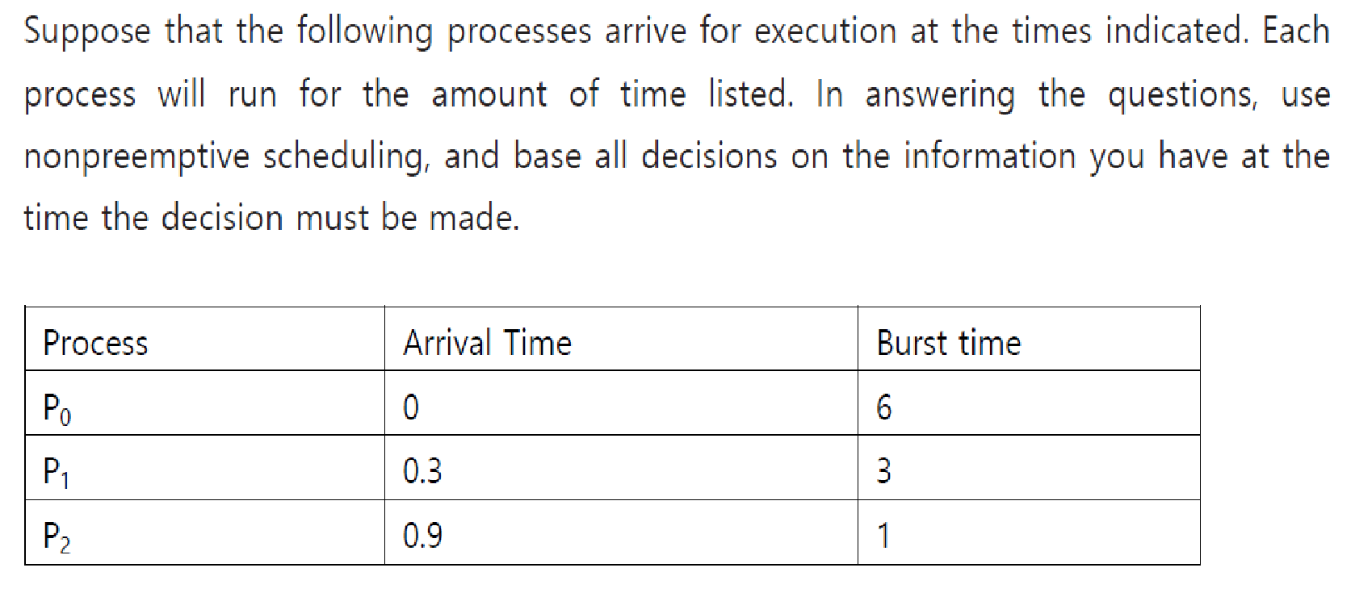

1. What is the **average turnaround time** for these processes with **Round Robin** scheduling algorithm with **time slice 2**?